Model Building
K-Means Clustering
K-Means Clustering is applied to group crops with similar soil nutrient and climatic characteristics. The algorithm identifies patterns in the dataset and helps understand the distribution of different crop categories based on the input features.
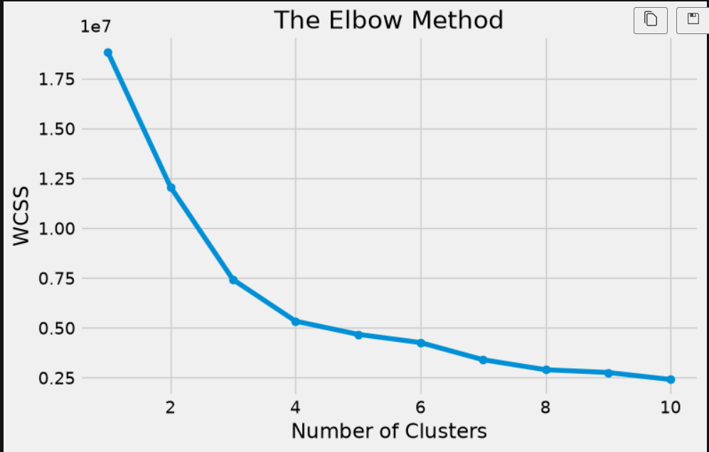
Logistic Regression
The Logistic Regression algorithm is implemented for crop prediction using agricultural environmental features. The model is trained using the fit() method and predictions are generated using the predict() function. Model performance is evaluated to analyze prediction accuracy and crop recommendation capability.
Evaluating Model Performance and Saving the Best Model
The trained model is evaluated using performance metrics such as Accuracy, Precision, Recall, and F1-Score. These metrics measure the effectiveness of the model in making correct predictions. After evaluation, the best-performing model is saved as model.pkl using the Pickle library for future use in the web application.
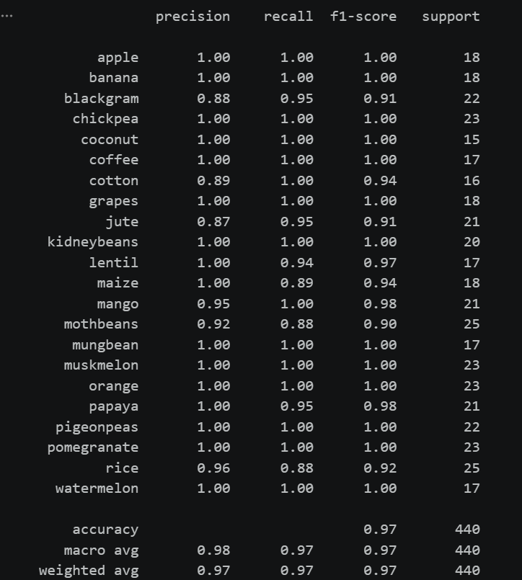
Predict the Best Crop Based on Given Parameters
The saved model is utilized to predict the most suitable crop based on the environmental and soil conditions provided by the user. Input features are collected from the user interface and passed to the trained machine learning model using model.predict().

